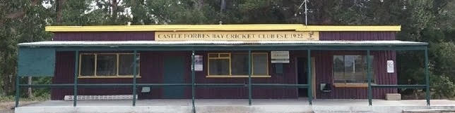
Castle Forbes Bay Recreational Club Inc.

26th July 2024

Dear Arts Tasmania,

I am writing to advise that the Castle Forbes Bay Recreation Club Inc endorses the CFBRC Art & Music 2025 Team to make an 'Organisations- projects' grant application to Arts Tasmania on behalf of the club for the purposes of staging the 2025 Art and Music Exhibition. Our club Treasurer is a member of the team and will therefore be in a position to support the committee and the team appropriately. As the president I am also hands on with the club and any events that we host.

Our club mission is to keep the clubhouse and grounds as a venue for community use, to promote local physical and mental health by maintaining the facilities, ensuring financial viability, coordinating volunteers, organising events and facilitating community use.

I know the CFBRC Art & Music 2025 Team are already working hard to make the 2025 Art and Music Exhibition a truly wonderful event for our club, local artists and the whole southern Tasmanian community. I am personally looking forward to the event for all the amazing art and music that is showcased and what it does for the community and local artists.

This grant would mean the world to the CFBRC Art & Music 2025 Team, local artists and the community alike. I hope that you can consider us as a grant recipient to help bring this wonderful community event to fruition.

Regards

Rob Ham
President

Castle Forbes Bay Recreation Club - 33 Meredith Street, Castle Forbes Bay

